Dis-Indo-Irian Jaya-Korwar-Biak

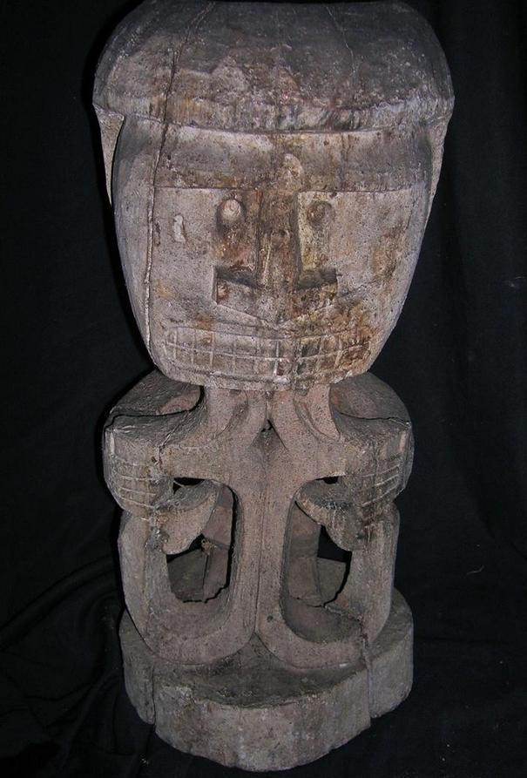

Case no.: Oceania

Accession Number:

**Formal Label:** Korwar ancestral wooden sculpture from Papua New Guinea, Cenderawasih, Geelvink Bay, late 19th –early 20th century.

**Display Description:**

**LC Classification:**

Date or Time Horizon:

Geographical Area:

**Map, GPS coordinates:**

Cultural Affiliation:

Media:

Dimensions: H 22 in

Weight:

Condition:

Provenance:

**Discussion:**

**References:**

Robert Cornell estate

# BIAK KORWAR RITUAL WOOD FIGURE W/SKULL HOLE 22"

# ANCESTOR FIGURE (Korwar) New Guinea, Cenderawasih (Geelvink) Bay region Late 19th-early 20th century Wood

KORWAR RITUAL FIGURE HOLE ON REAR OF HEAD FOR INSERTION OF SKULL EARLY YEARS OF RITUAL USE-VERY WORN FROM USE- YEARS OF USE AND PATINA,

|  |  |
| --- | --- |
| ORDER DATE  Oct 08, 2015 | ORDER TOTAL  US $89.99  + US $17.76  shipping  **Order 0** [Leave feedback](http://feedback.ebay.com/ws/eBayISAPI.dll?LeaveFeedbackShow&useridto=primitifstuff&transactID=0&item=221902128113&_trksid=p2057872.m2749.l2665)[View order details](http://payments.ebay.com/ws/eBayISAPI.dll?ViewPaymentStatus&transId=0&itemid=221902128113&_trksid=p2057872.m2749.l2673)  [More actions](http://www.ebay.com/myb/PurchaseHistory) |

1 item sold by[primitifstuff](http://www.ebay.com/usr/primitifstuff?_trksid=p2057872.m2749.l2754)

|  |  |
| --- | --- |
| [BIAK CAVE FIGURE SKULL HOLE 26"](http://www.ebay.com/itm/221902128113?_trksid=p2057872.m2749.l2649&ssPageName=STRK%3AMEBIDX%3AIT)  ( 221902128113 )  Delivered on Fri, Oct 16  Tracking number: [**Tracking number**9405509699937975115807](javascript:;)  [Add note](javascript:;) | ITEM PRICE:  US $89.99 |

